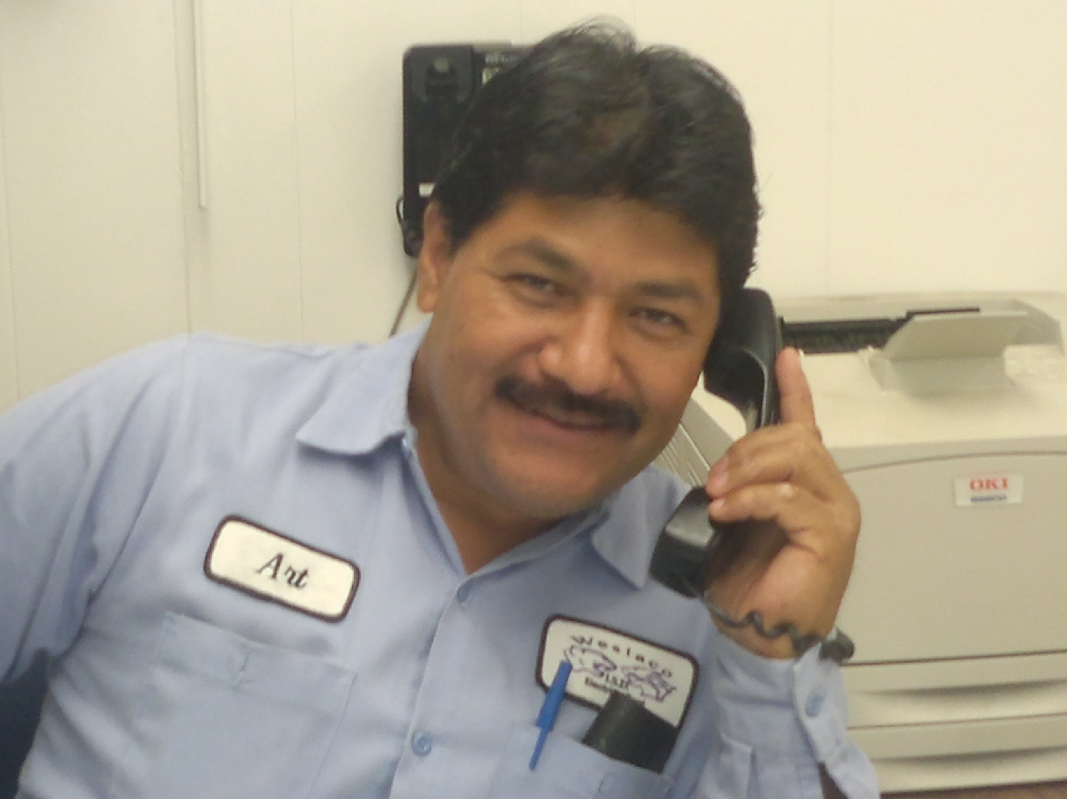
Arturo Caberra
Electrical Specialist at W.I.S.D.
Maintains Electrical Power
To all W.I.S.D. schools and Building

Electrical Duties

Inspect and repair all electrical systems throughout the district. Complete repairs as requested on work order or by supervisor. Inspect and repair all electrical installations throughout the district. Perform all other duties as assigned.



