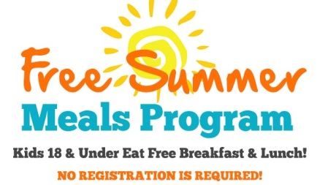

Dear Parent or Guardian:

When school is out…students are still hungry!

Weslaco ISD is meeting nutrition needs by serving Free Breakfast & Lunch to ALL children age 18 and under during the Summer Break.

2018 Summer Feeding Program Sites
SCHOOL | BREAKFAST TIME | LUNCH TIME | DATE
Margo Elementary  1701 S. Bridge | 7:30 am – 8:30 am | 11:00 am – 12:30 pm | Monday – Thursday  June 5 – June 28, 2018  ACE June 4 – July 12, 2018
Cleckler-Heald Elementary  1601 W. Sugarcane Dr. | 7:30 am – 8:30 am | 11:00 am – 12:30 pm | Monday – Thursday  June 5 – June 28, 2018  ACE June 4 – July 12, 2018
N. Bridge Elementary  2001 N. Bridge Ave. | 7:30 am – 8:30 am | 11:00 am – 12:30 pm | Monday – Thursday  June 5 – June 28, 2018  ACE June 4 – July 12, 2018
Roosevelt Elementary  814 E. Plaza | 7:30 am – 8:30 am | 11:00 am – 12:30 pm | Monday – Thursday  June 5 – June 28, 2018  ACE June 4 – July 12, 2018
Sam Houston Elementary  608 N. Cantu | 7:30 am – 8:30 am | 11:00 am – 12:30 pm | Monday – Thursday  June 5 – June 28, 2018
B. Garza Middle School  1111 W. Sugarcane Rd | 7:00 am – 8:30 am | 10:30 am – 12:30 pm | Monday – Thursday  June 5 – June 28, 2018
Central Middle School  506 E. Sixth St. | 7:30 am – 8:30 am | 11:00 am – 12:30 pm | Monday – Thursday  June 5 – June 28, 2018
Weslaco High School  1005 W. Pike | 7:00 am – 8:30 am | 10:30 am – 12:30 pm | Monday – Thursday  June 4 – July 6, 2018
Weslaco East High School  810 S. Pleasantview | 7:30 am – 8:30 am | 11:00 am – 12:30 pm | Monday – Thursday  June 4 – July 6, 2018

SITE | LUNCH TIME | DATE
Sunrise Hill Park  FM 1015 Mile 11 N. & 1 ½ W | 11:00 am – 11:30 pm | 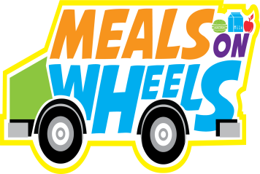  Monday – Friday  June 4 – July 13, 2018
Gibson Park  301 S. Border Ave. | 12:00 pm – 12:30 pm | Monday – Friday  June 4 – July 13, 2018
Isaac D. Rodriguez Park  1200 E. 6th Street | 12:45 pm – 1:15 pm | Monday – Friday  June 4 – July 13, 2018

For more information about the Weslaco ISD Summer Feeding Program, please contact the Food & Nutrition Services office at (956) 969-6593.
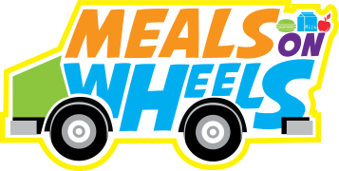
Sincerely,

Dora Peña, MS, RDN, LD
Food & Nutrition Services Director

This institution is an equal opportunity provider.

