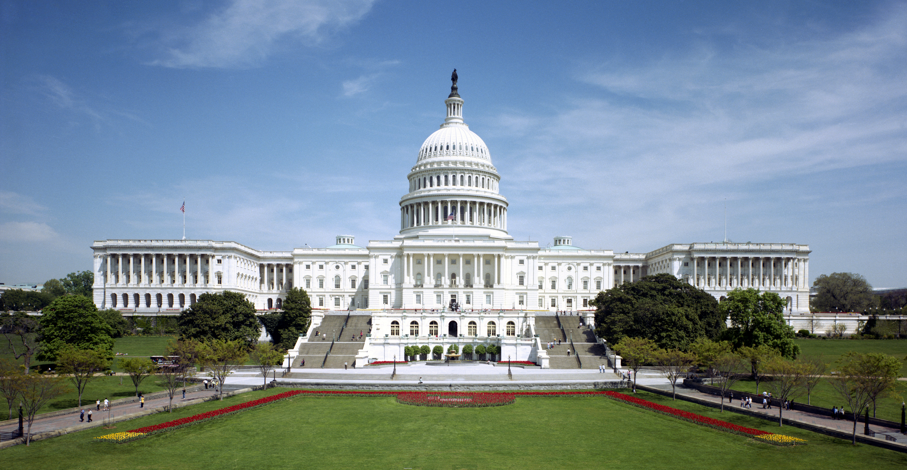  CLOSE-UP  wASHINGTON d.c. & New York city  June 24-July 1, 2018  High School Program  Students will participate in “hands on” approach and explore civic responsibility as well as gain a greater understanding on how democracy works in the United States of America. Students will also participate in leadership workshops that address community issues, student led–mock congress and issues regarding the economy. Students will also visit the numerous national monuments in Washington D.C. and New York City.  (Student must meet academic eligibility for this program)  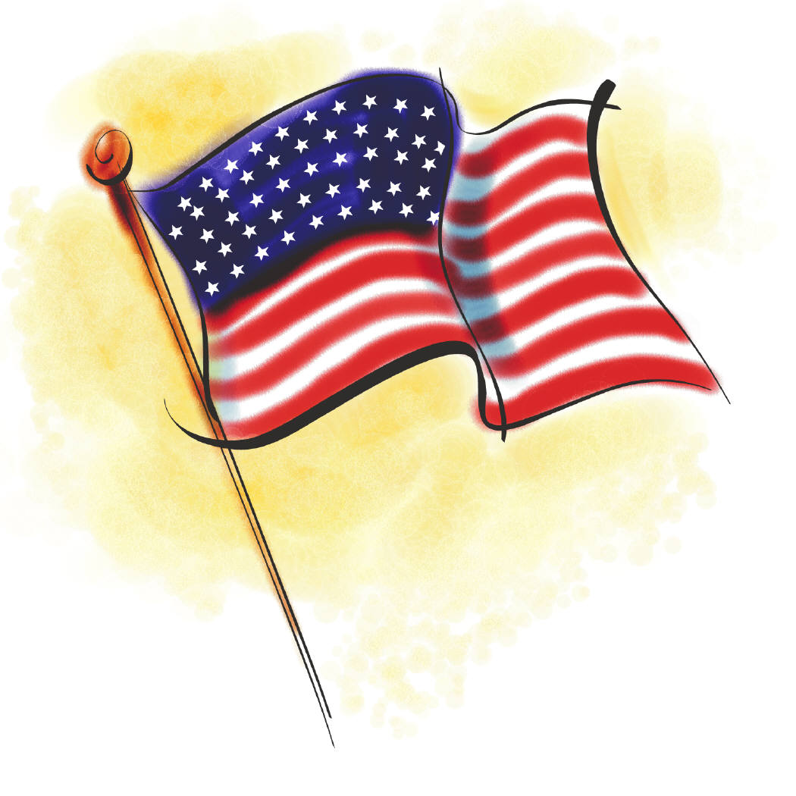 | Secondary Migrant Summer Program  ────  Weslaco High School  8th -12th Grade  ────  Workshop Dates  June 5, 6, 7, 2018  June 12, 13, 14, 2018  8:00 am--3:00 pm  Breakfast & Lunch will be provided at  WHS cafeteria  ────  Transportation will be provided!  wESLACO mIGRANT dEPARTMENT  400 S. OKLAHOMA  956-969-6625  Mrs. Mary Mendoza  Mr. Jose Baron  Mr. Armando Gonzalez  mmendoza@wisd.us

